**Assignment 1**

**Student Name : Farsheed Rahman, S.M. Arif Mahmud, Md Tuhin Al Jobayer, shahria sultana, Md. Abrarul Karim**

**Student ID : 1830360, 1830398, 1831124, 1920280, 2022521**

**Course ID : CSE307**

**Course section : 03**

**1. Easy Fund (Crowd Funding App)**

**2. Project objectives and Goal:**

* **Facilitate Funding:** The primary objective of the app is to provide a platform where project creators can create funds where can raise necessary funds for their ideas, products, or causes and from a wide audience of backers.
* **Empower Creativity and Innovation:** The app should encourage and support creative and innovative projects by giving aspiring entrepreneurs, artists, and individuals a chance to bring their ideas to life without traditional funding barriers. Users can create a room where they can talk about their problems to a counselor.
* **Accessibility and Inclusivity:** The app should democratize the funding process, making it accessible to people from all walks of life and geographical locations in Bangladesh.
* **Donating a social cause:** The Fundraiser can create a post for social and humanitarian cause where donors/backers can donate.
* **Trust and Transparency:** Establishing trust is crucial for the success of a crowdfunding app. It should implement measures to ensure transparency between project creators and backers, providing regular updates on project progress. The backers pay the fund through App so the system or App has the liability or responsibility to maintain the Trust.

**3. History Leading to Project Request:**

Mental health is a rising problem in Bangladesh. It was a prevalent problem in the country but the after the Corona virus pandemic the population is now become more vulnerable to mental health disorders. One study has found that the prevalence of depressive (57.9%), stress (59.7%) and anxiety (33.7%) symptoms in the adult population is now much higher than pre-pandemic rates. And with the low amount of psychiatric help people get, this app will help them with their. People who have mental illness can talk through this app to volunteers, professional counselors and people with the same illnesses.

**4. Problem, Solution & Opportunities:**

*Problem(s)

1. As it is a web based app, there should be an internet connection.

2. Without browser the system will not run.

3. Volunteers may not be available all the time.

*Solution(s)

1. Device must have connected internet

2. Device must have browser.

3. Volunteers will get notification through email/SMS when someone creates a room according to their tag.

*Opportunities

1. User registration is very simple, it will never ask for sensitive or private information

2. Users can stay anonymous.

3. During counseling as the chat is in real time so the users will not be waiting for reply.

4. No complexity in using this System.

5. All the operations of the system will be very user-friendly.

**5. Product Description:**

1. Product Summary

This app will be able to help people with mental illness. There will be a real time messaging app where the patients can talk with volunteers about their problems. Users can create rooms, with their specific tags and requirements. In this room, the patients can chat with volunteers and also with other patients who share the same problems. If the patient needs professional help according to the volunteers, they can book appointments for a professional counselor.

1. Product Stakeholders

All and Every kind of People can be the User of This Product.

1. Context Level Data Flow Diagram:

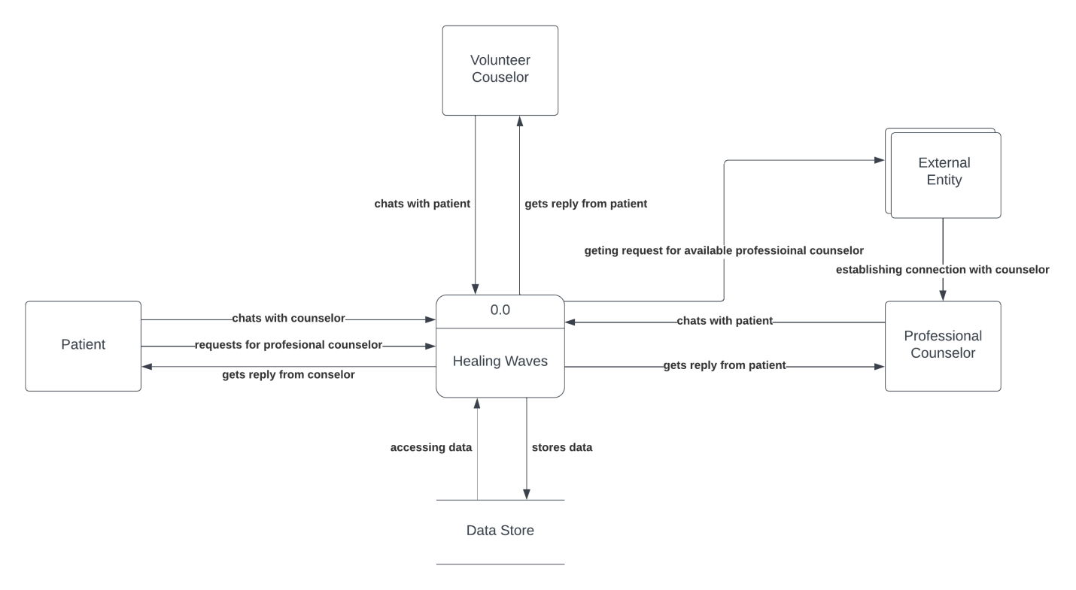

1. For now we are using this as a browser based Web-application.

| Operating System | Software | Hardware |
| --- | --- | --- |
| Windows OS, Mac OS, Android OS | Chrome, Firefox, Safari, Opera | 800 MHz Processors, 512 MB ram, Broadband connection. |

1. Software key technical features

Login interface: Here the users will register and input their information. Then they can login to the system with the relevant information.

Dashboard: Patients will be able to see volunteer available, create room and also will be able to talk through the messaging app. Volunteers will be able to see if there is a room created where they can help, Create rooms and talk with patients through the messaging app. Volunteers will also get notifications when they login if they are requested in a room. Professional Counselor can see the list of patients they have, the time of their appointments with the patients. All of the users will be able to logout.

Reminder/Notification: Volunteers will get notifications if a room is created with their specific tag and if they are needed for real time messaging with the patients. Professional counselors will get notification when they are booked for an appointment. They will get a reminder about 30 minutes before the appointment.